



PowerBoss Inc
14N845 US HWY 20 Pingree Grove, iL 60140
Phone: 800-323-9420 Fax 800-422-6933
www.powerboss.com

Product Bulletin

To: Valued PowerBoss Customers

From: PowerBoss Sales Support

Date: 10/25/2018

Subject: Nautilus Non-Marking Tire

Improvement

A tire for the Nautilus and the Nautilus HD that is made of a material to not leave marks on the floor during operation.

Applicable Models/Serial Numbers

PB45GAS PB45HGAS
PB45LP PB45HLP
PB45DSL PB45HDSL

Reference Kit Instructions – For Installation Procedure

Front Tire: 3316330-NM

Rear Tire: 731420-NM Two are required for the Rear.
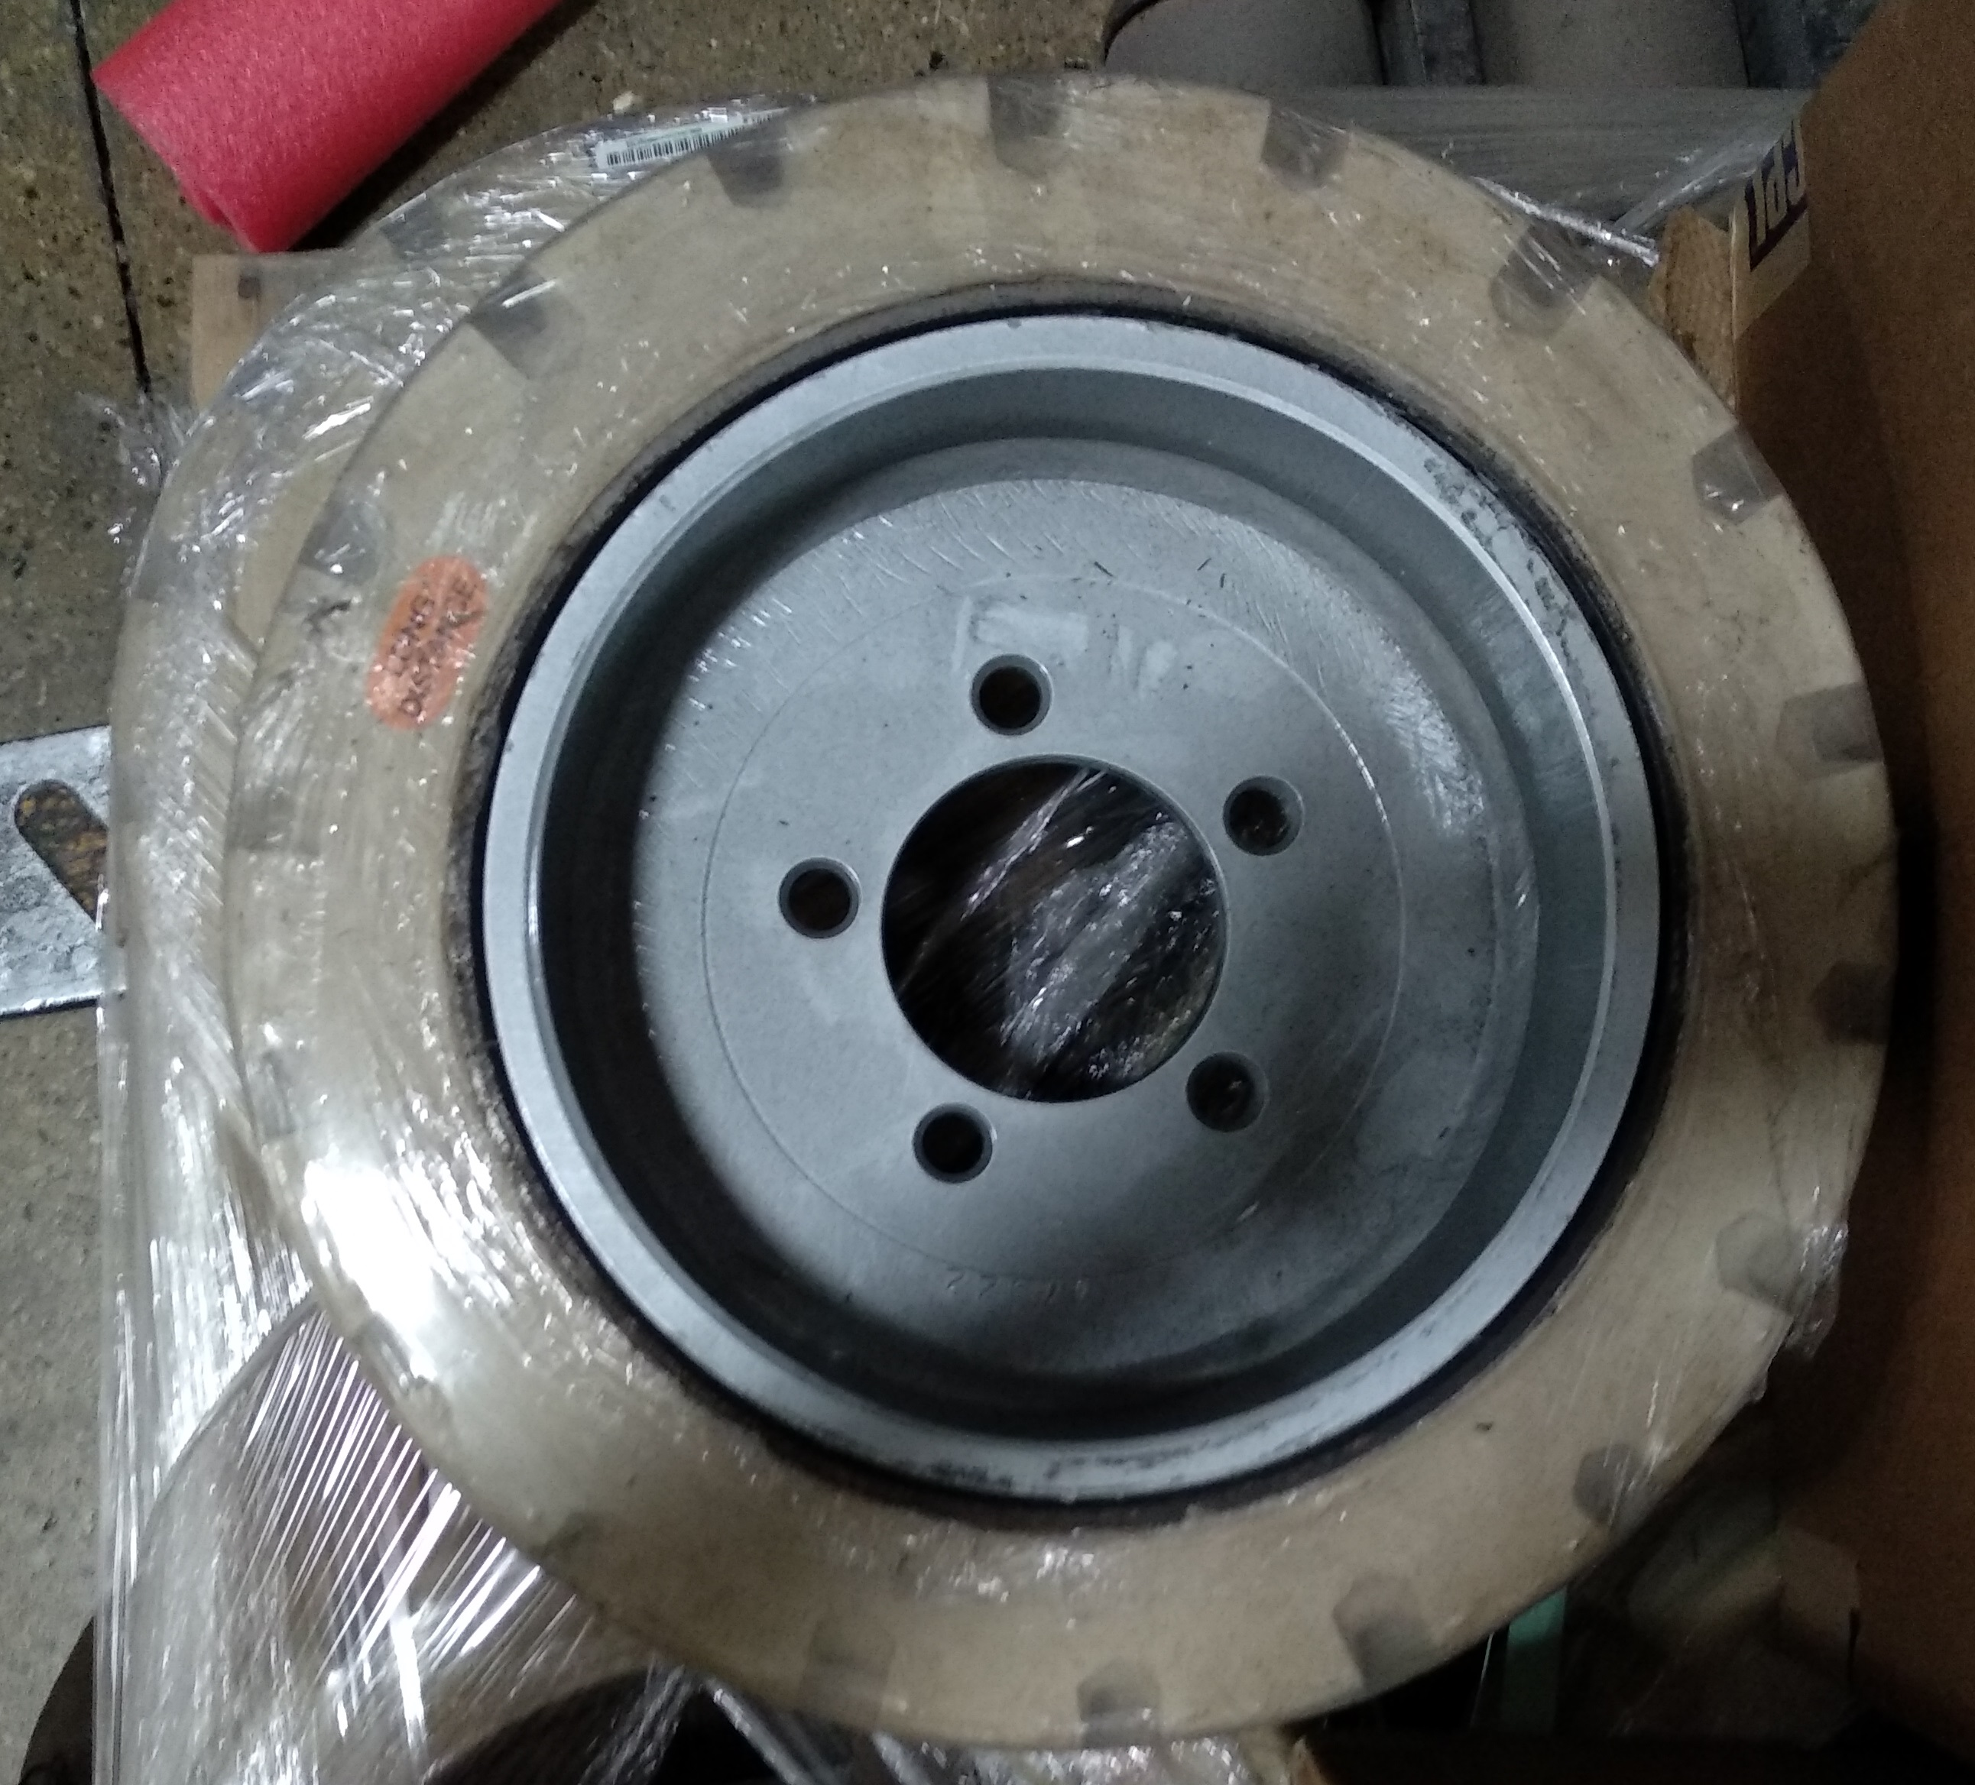
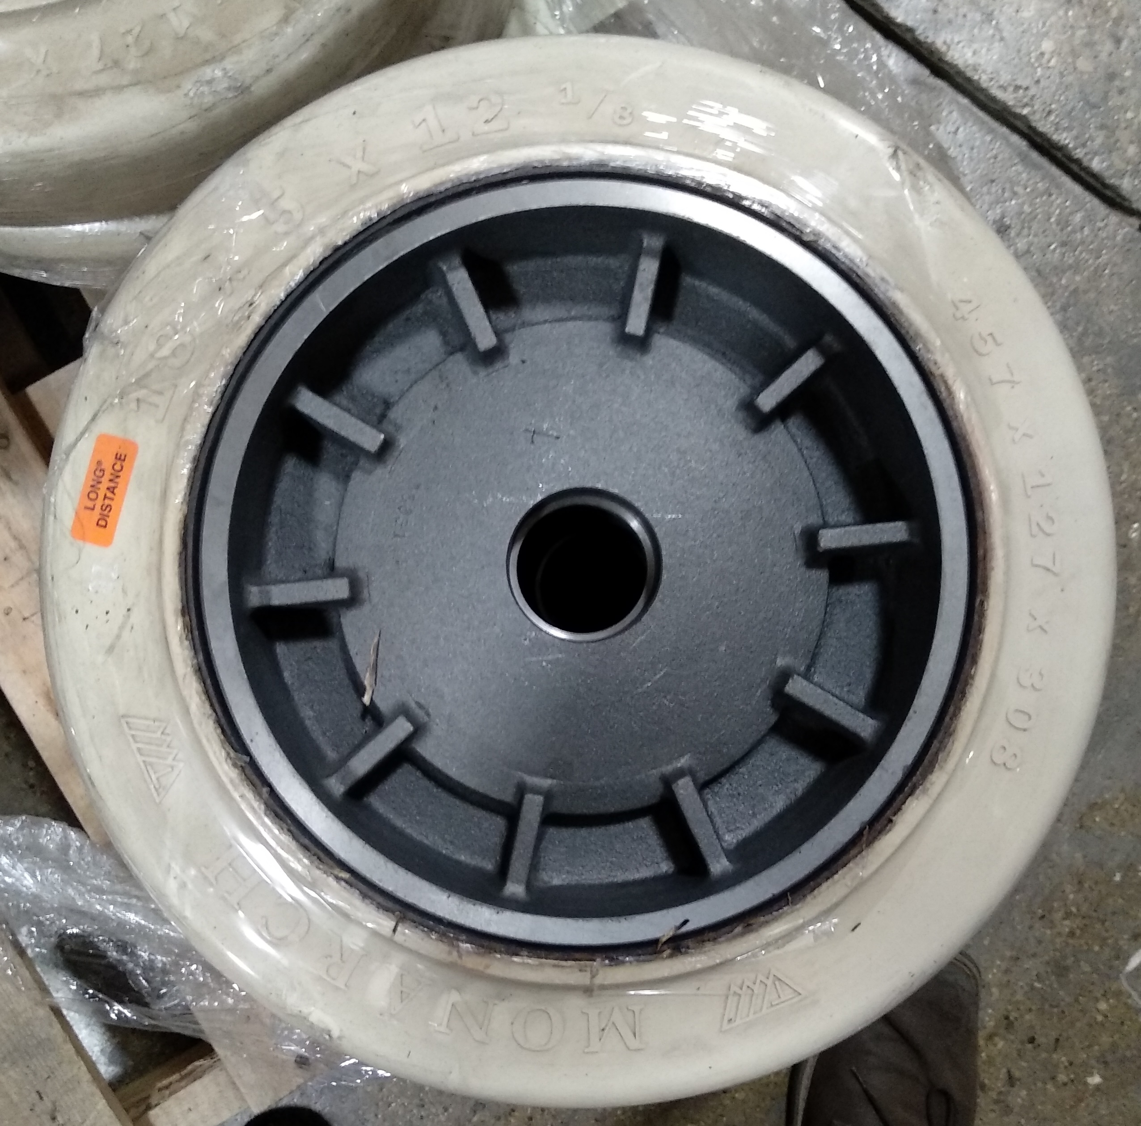

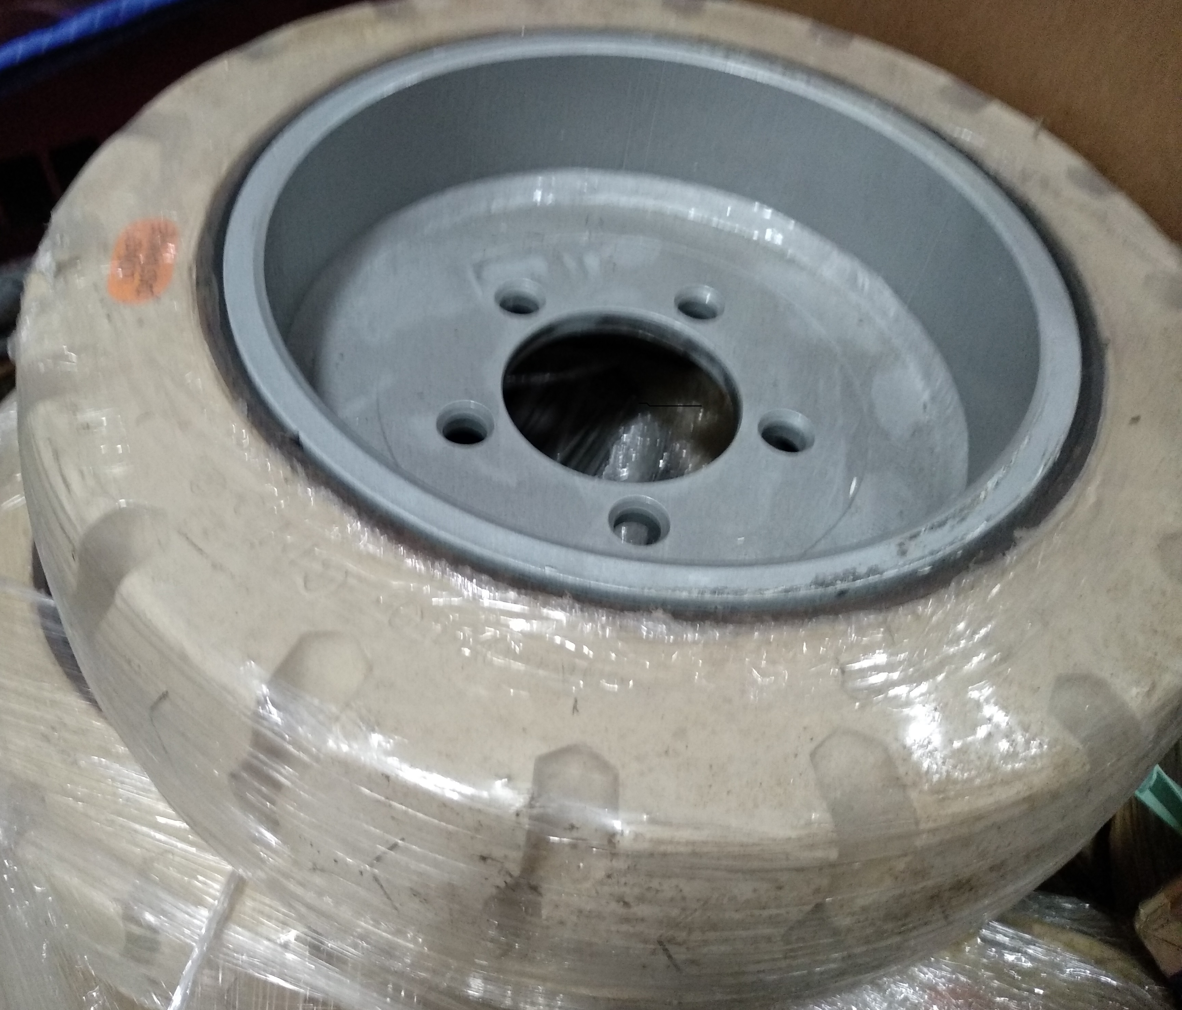
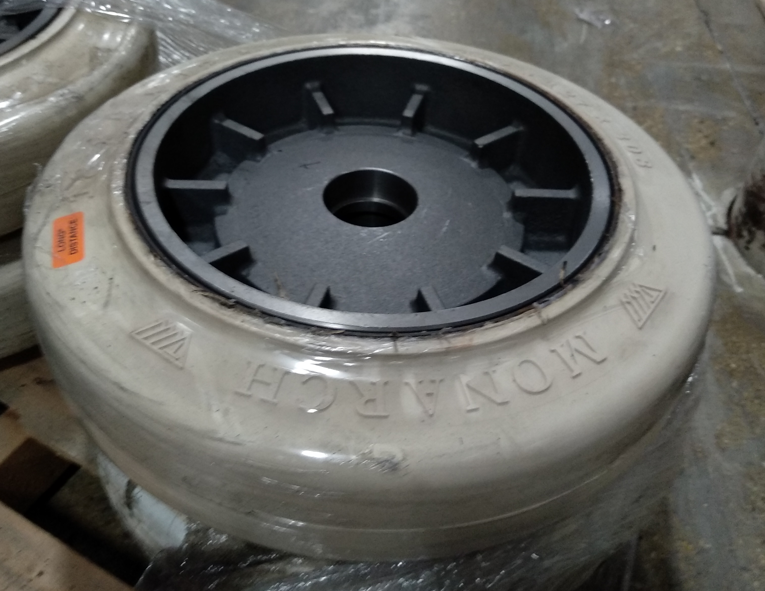
FRONT TIRE REAR TIRE
For further assistance, questions, or comments contact PowerBoss Inc at 800-323-9420 (USA)

